

**2020+ Explorer ST Rear Differential Brace instructions**

**Pre Assembly**

* Prior to installation, Press the two piece Diff brace bushings into the oval shaped holes on both sides of the Diff mount bracket.
* Once bushings are installed on both sides press in the two threaded bushing inserts so the 19mm nut is facing away from the posts on the bracket. (Refer to photos 1-3)

**Installation**

1) Remove the 6 lower bolts on the diff cover using an E18 inverted Torx socket.

2) Next install the two shorter 12mm bolts with a slim black spacer loosely onto the top two holes in diff cover. (Refer to photo 4)

3) Slide Livernois Diff brace bracket into place behind the differential cover and snug top two bolts to hold the bracket in place, Once bracket is in place install the four longer 12mm bolts with blue Loctite into the lower four holes in the diff brace bracket.

4) Torque all diff brace hardware to 25ftlbs.

5) Then install the three frame connector plates into the three open holes in the rear sub frame making sure all frame connector plates run parallel to sub frame channel.

6) Using the three shorter 15mm bolts loosely fasten the Livernois sub frame bracket to the sub frame connector plates, Make sure the Livernois motorsports logo is facing the rear of the vehicle and the lower portion of the slope on the top of the bracket is facing forward. (Refer to photos 6-7)

7) Once sub frame bracket is loosely installed use the two longer 15mm bolts with blue Loctite and two washers on each side and one big washer, place them through the sub frame bracket and into the threaded bushing inserts on the diff bracket.

8) Torque the through bolts to 20ftlbs, and then torque the sub-frame bracket bolts to 20ftlbs.

* Make sure that all hardware is correctly installed before fully torqueing hardware failure to do so may result in damaged hardware.

9) Finally the two through bolts can be torqued to 60ftlbs and the three sub frame bracket bolts to 50ftlbs

**Installation complete!**

**\*We recommend checking the torque on all hardware after 100 miles of driving.**

**Tools Required:**

E18 Inverted Torx

12mm Socket  
12mm Wrench

15mm Socket

Thin 19mm Wrench

**Parts list:**

2x LME 931011-BS0 (outer bushing support)

2x LME 931011-BSI (inner bushing support)

1x LME 931011-D (Differential side)

1x LME 931011-S (Sub frame side)

3x LME 931011-T (T slot)

2x LME 931011-BL (Bushing liner)

4x ENE3171-1G (Bushings)

2x ARP HM12AM45-5C (12mm hex head, 45mm long, “short bolt”)

4x ARP HM12AM70-5C (12mm hex head, 3in long, “long bolt”)

3x ARP H6AR1.500.1 (15mm hex head, 1.5in long, “short bolt”)

2x ARP H6AR3.250-1 (15mm hex head, 3.75in, “long bolt”)

2x ARP 200-8703 (Flat washer)

5x ARP 200-8513 (chamfer washers)

6x ARP 200-8770 (Black washers)

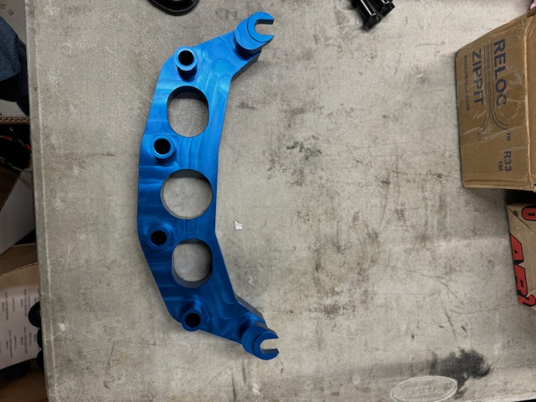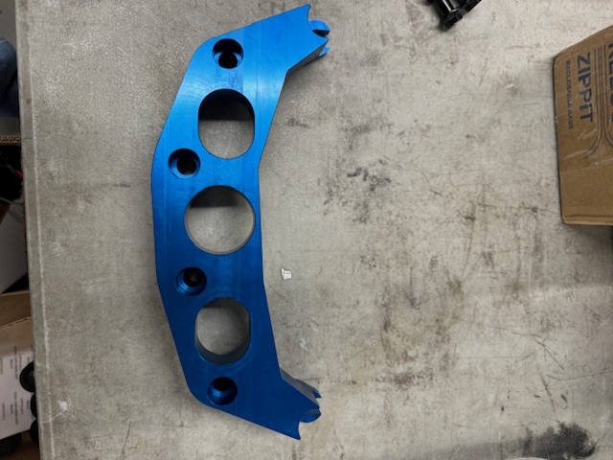

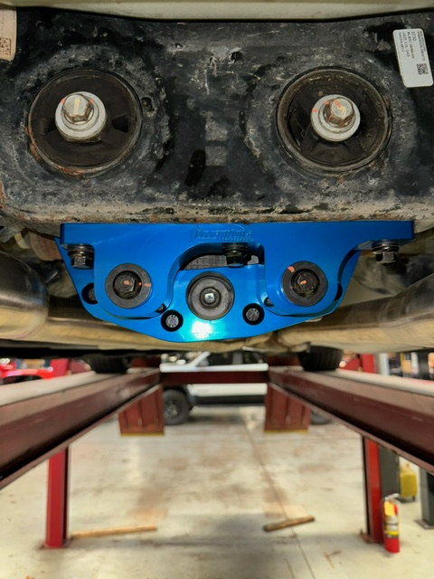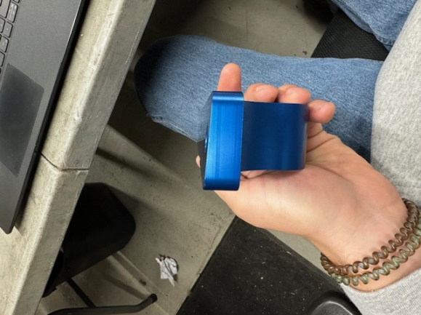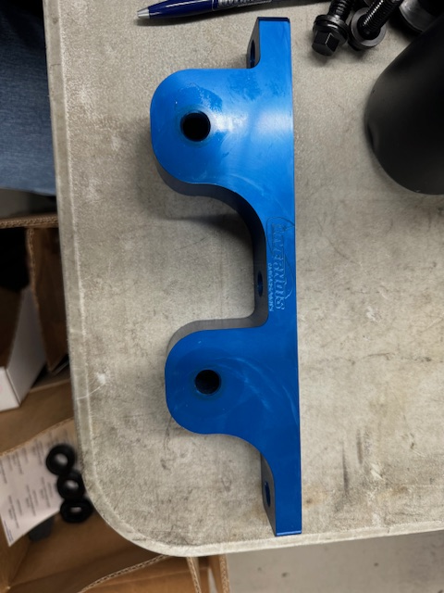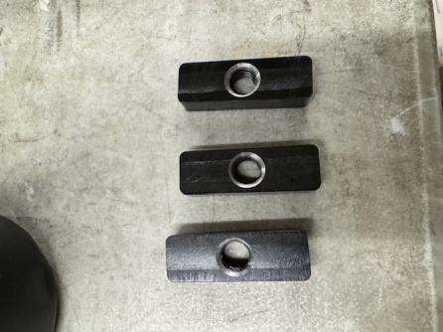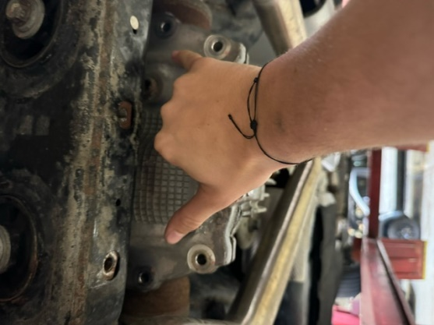

8

2

1

7

6

5

3

4

